**Ganpat University**

**Faculty of Engineering & Technology**

**Computer Science & Engineering**

**(2CSE204) Basics of Operating System and Shell Scripting**

***Name:- Dwij Vatsal Desai***

***Sem:- 2***

***Sub: - BOSS***

***Enrollment No.:- 23162121027***

***Prac:- 7***

***Date:- 06/04/2024***

**Practical 7**

1. There is a directory named ***attendance*** and its group owner is ***your_name***.

***Command:-***

mkdir attendance

sudo groupadd Dwij

sudo chgrp Dwij attendance/

ls -ld attendance/

***Screenshot:-***

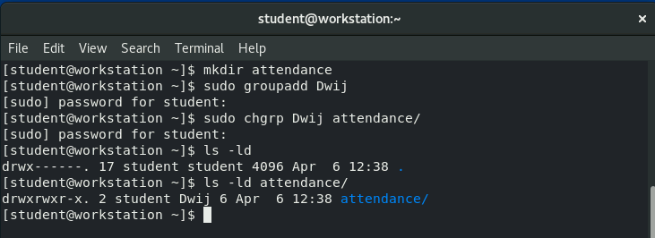

1. The group **teaching** contains four members named **user1** to **user4**.

***Command:-***

sudo useradd uSer1

sudo useradd uSer2

sudo useradd uSer3

sudo useradd uSer4

sudo groupadd teaching

sudo usermod -aG teaching uSer1

sudo usermod -aG teaching uSer2

sudo usermod -aG teaching uSer3

sudo usermod -aG teaching uSer4

groups uSer1 uSer2 uSer3 uSer4

***Screenshot:-***

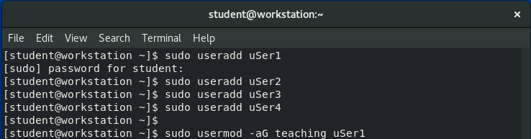 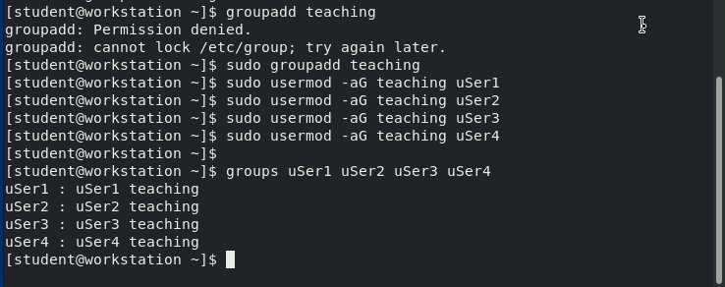

1. The ***attendance*** directory contains four files **BOSS, CO, BCS and LA**. The group owner of all these files should also be ***your_name***

***Command:-***

cd attendance

touch BOSS CO BCS LA

ls

sudo chgrp Dwij BOSS

sudo chgrp Dwij CO

sudo chgrp Dwij BCS

sudo chgrp Dwij LA

ls -ld BOSS CO BCS LA

***Screenshot:-***

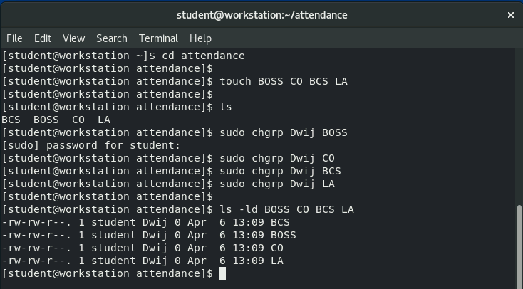

1. Following mapping should be applied on users and files with write access, and the same should be the owners of respective files:

    BOSS: user1

    CO: user2

    BCS: user3

    LA: user4

***Command:-***

sudo chown :uSer1 BOSS

sudo chown :uSer2 CO

sudo chown :uSer3 BCS

sudo chown :uSer4 LA

ls -l

***Screenshot:-***

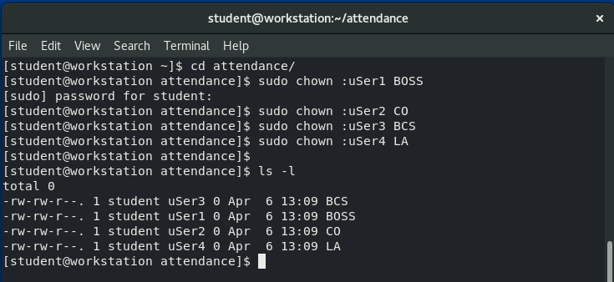

1. Only the owners of these files should be able to delete the files inside the attendance directory.

***Command:-***

sudo chmod +t BOSS

sudo chmod +t CO

sudo chmod +t BCS

sudo chmod +t LA

ls -l

***Screenshot:-***

